

Introduction :

Bright Ideas Consulting Ltd. creates innovative, evidence-based solutions, to enable organisations and the individuals who interact with them to thrive. We predominantly work with organisations who have a social mission including voluntary & community sector organisations, public sector agencies and social business. Our main areas of services include; Organisational Development & Change Research Evaluation & Impact Assessment Strategy & Business Planning Financial Sustainability & Income Diversification for voluntary sector organisations and social enterprise Psychometric Assessment Psychological Research

Purpose of Bright Idea Consulting :

Bright Ideas can help you when you need us - you might have a staff shortage and need an experienced senior professional to help deliver your development requirements . This might mean a helping hand during a merger, a reorganisation, cover for maternity leave or to fill a gap after a senior member of staff has left . We can be brought in on a short-term basis to help offer strategic and practical help, as required. Project development and management You might also want a second opinion on an important scheme, or want some help getting a scheme going (no matter how large or small) and need some extra resource. Bright Ideas can call upon experienced professionals to help you with all aspects of development and can advise on all areas related to housing developments, including: • strategy • public sector and HCA issues • scheme risk analysis and appraisal • design • cost • procurement New homes development Bright Ideas is looking for sites to develop. We are keen on progressing smaller, niche sites for sale and also offering our services for larger joint venture arrangements. If you need a partner, some advice or want to sell a site, get in touch with us today.

Consultants are people who are trained in recognizing problems

and shaping solutions to those problems. This training is founded

on a successful work career that has developed skills and maturity

within the individual.

Like most professions though, these possessed skills must be focused and honed to apply the challenges of consulting to a variety of businesses. Successfull consultants continually study and learn their craft.

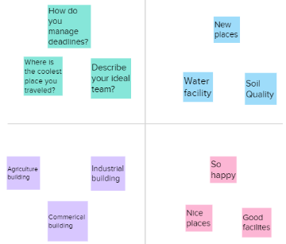

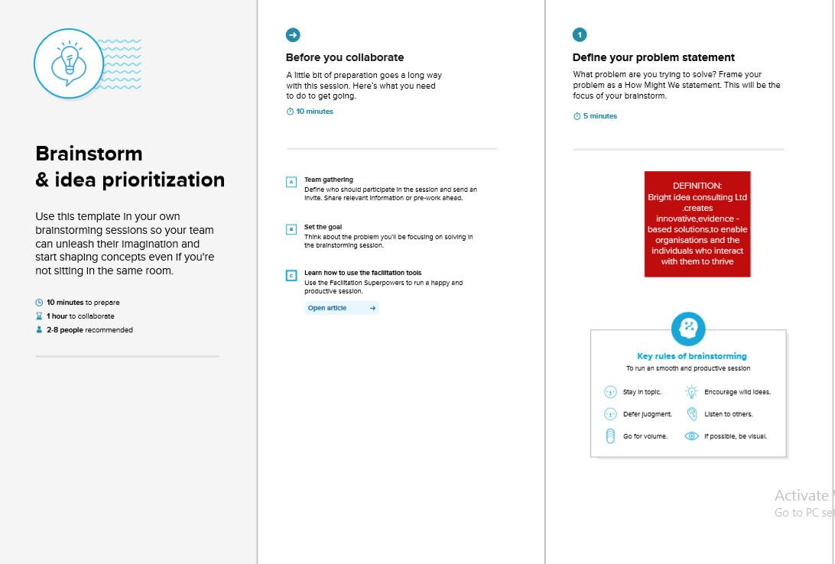

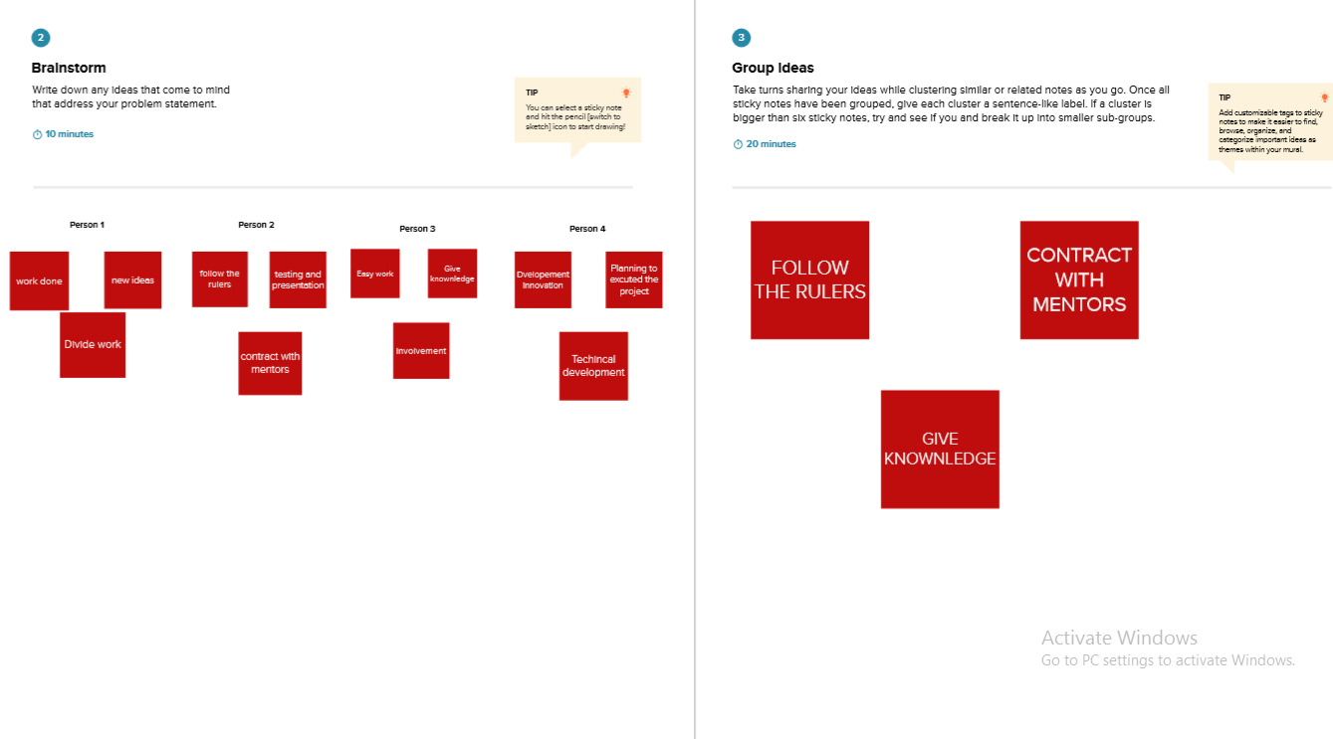

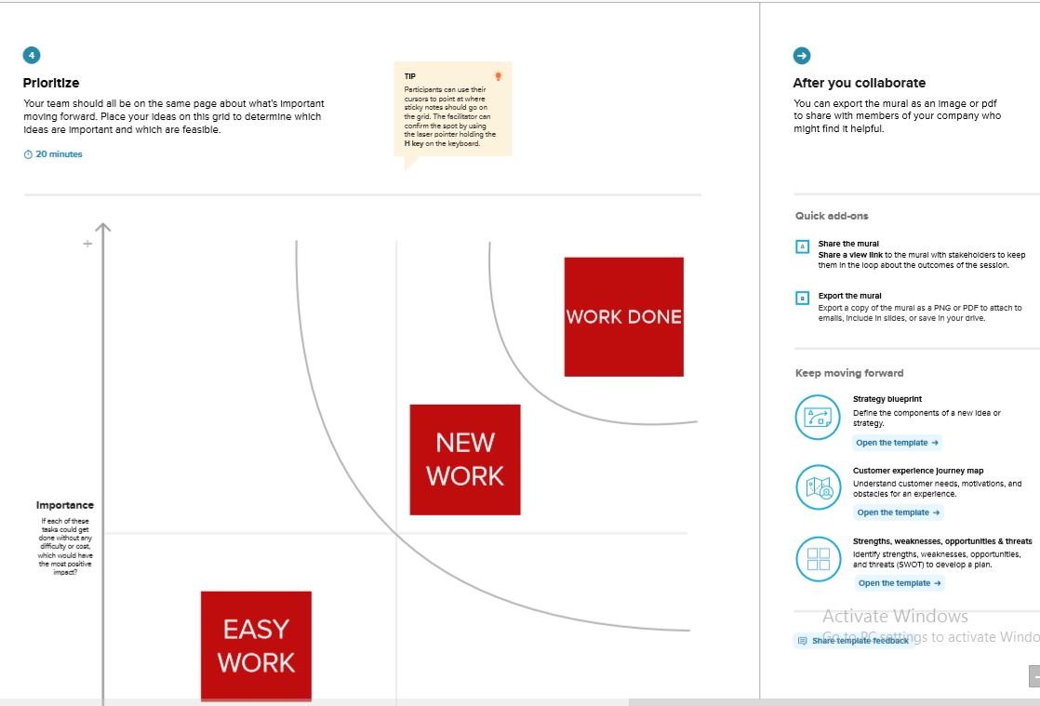

Advantages of bright idea consulting:

As a Certified Business Advisor, I have participated in continually adding information and training to my current experience to provide the most comprehensive base of knowledge available to you and your business.

The Team of Certified Business Advisors at Bright Ideas Consulting have years of experience in the areas of:

Business Process Development

Project Management

Financial Analysis

Communication

Training & Development

Customer Service and improving the customer experience

Policies & Procedures documentation and training

Human Resources

Marketing

Our company is built on the principles of creating long term professional relationshps with our clients and providing reliable service for years to come.

Disadvantage of bright idea consulting :

Organisations are turning their recruitment efforts to an overlooked community of neurodiverse talent that will challenge their workforces to think and perform in different ways. As organisations become more diverse, awareness of what may be termed as “invisible difference” has increased. And accepting neurodiversity—the way individuals think differently—is part of the agenda. It is often used as a reference point for people who are on the autistic spectrum or those with ADHD, but the concept goes further than this. If employers proactively seek people who think differently, they may find the skills which will greatly benefit their organisations.

Result:

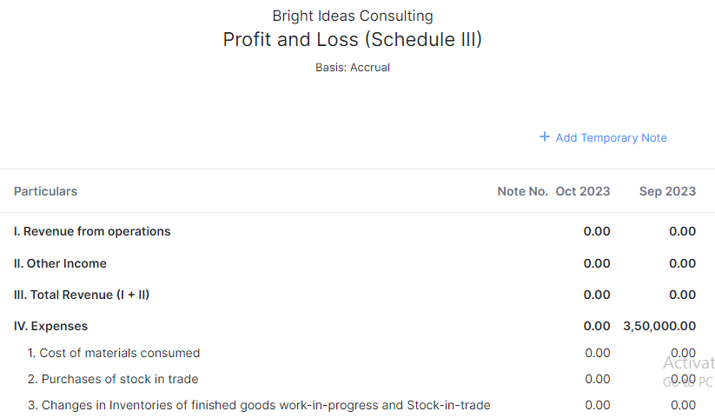

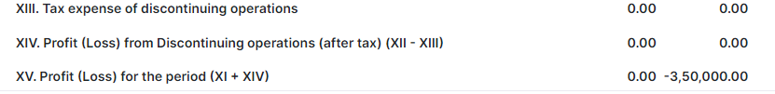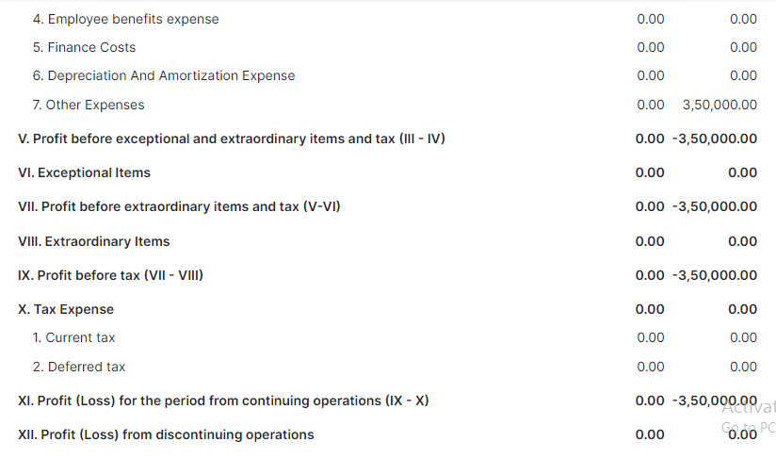

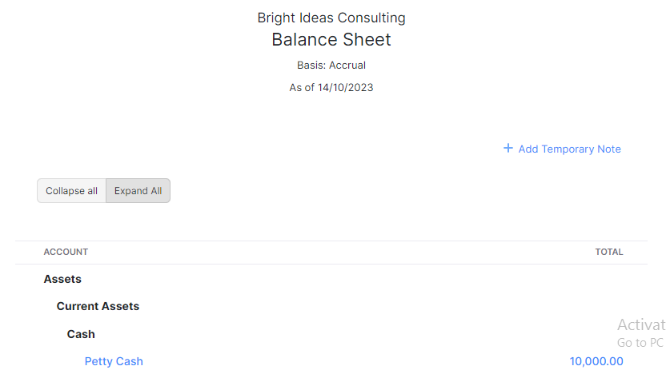

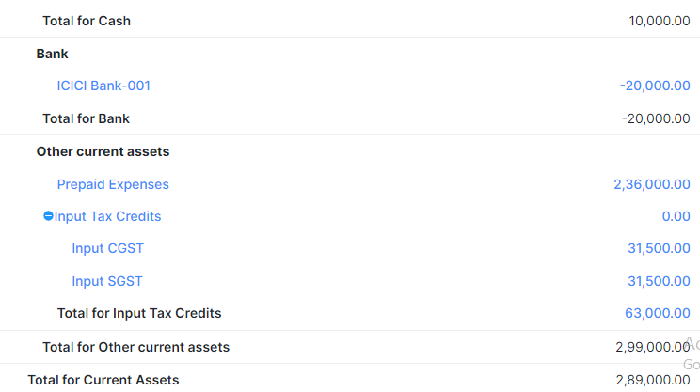

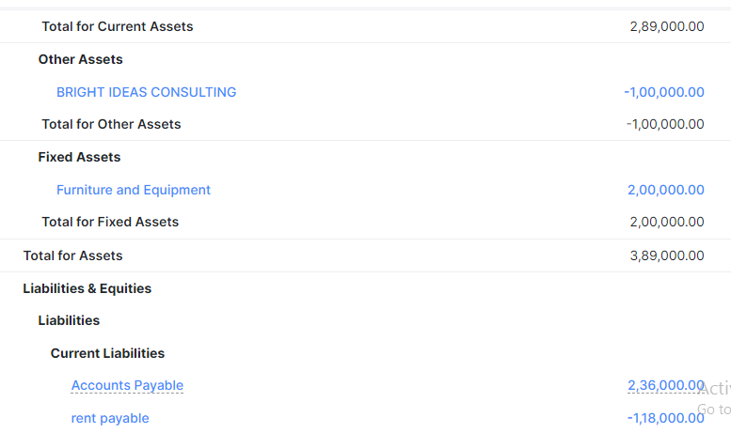

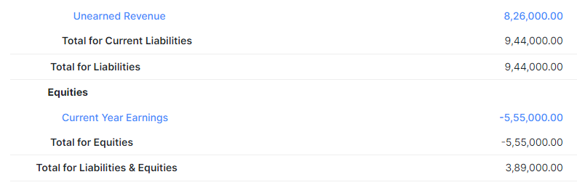

Conclusion:

Is usually meant to measure revenue compared to cost. But for events that generate sales leads for a business or raise awareness for a cause, ROI can be adjusted to calculate the net value of your efforts.

I hope you have taken away some valuable information from this series to help with your event planning. However, if you feel like you need a little more help from an industry professional, just a reminder, you can book Bright Ideas for event consulting services with as many or as few aspects that you need help with. Think of our event consulting services as a menu in a restaurant. You can choose what you want and need the most help with.

It depends on what you need. You can purchase a package for a few hours if you need just a bit of guidance. However, if you need someone to map out the whole event plan and implement it, I can do that for you too.